Boolean Data Types
# Source: AI Source: Provided by: [Data Path: Persons Table -> ID Column: 1, Name_En Column: Motasem Essam] -> From: [Chatgpt (GPT‑5 Mini)] on [12/10/2025]
A Boolean (bool) is a data type that stores only two possible values:
- True
- False
It is mainly used in decision making, conditions, and logical operations in programming.

Key Characteristics
# Source: AI Source: Provided by: [Data Path: Persons Table -> ID Column: 1, Name_En Column: Motasem Essam] -> From: [Chatgpt (GPT‑5 Mini)] on [12/10/2025]
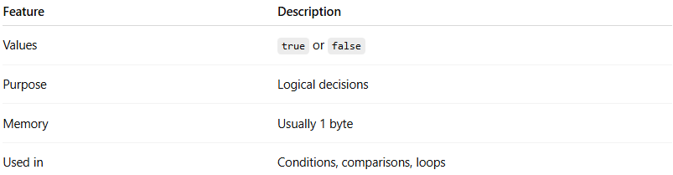
Feature | Description
Values | true or false
Purpose | Logical decisions
Memory | Usually 1 byte
Used in | Conditions, comparisons, loops

Example Boolean Values
# Source: AI Source: Provided by: [Data Path: Persons Table -> ID Column: 1, Name_En Column: Motasem Essam] -> From: [Chatgpt (GPT‑5 Mini)] on [12/10/2025]
true
false

Example in Programming

C / C++ / Java
# Source: AI Source: Provided by: [Data Path: Persons Table -> ID Column: 1, Name_En Column: Motasem Essam] -> From: [Chatgpt (GPT‑5 Mini)] on [12/10/2025]
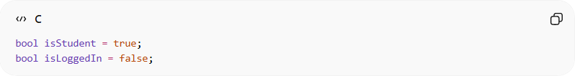
bool isStudent = true;
bool isLoggedIn = false;

Python
# Source: AI Source: Provided by: [Data Path: Persons Table -> ID Column: 1, Name_En Column: Motasem Essam] -> From: [Chatgpt (GPT‑5 Mini)] on [12/10/2025]
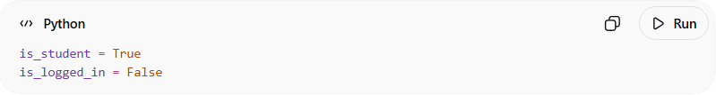
is_student = True
is_logged_in = False

Boolean in Conditions
# Source: AI Source: Provided by: [Data Path: Persons Table -> ID Column: 1, Name_En Column: Motasem Essam] -> From: [Chatgpt (GPT‑5 Mini)] on [12/10/2025]
Booleans are commonly used in if statements.
Example:
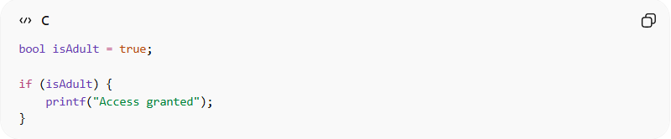
bool isAdult = true;

if (isAdult) {
printf("Access granted");
}

Boolean from Comparisons
# Source: AI Source: Provided by: [Data Path: Persons Table -> ID Column: 1, Name_En Column: Motasem Essam] -> From: [Chatgpt (GPT‑5 Mini)] on [12/10/2025]
Booleans are often produced from comparison operations.
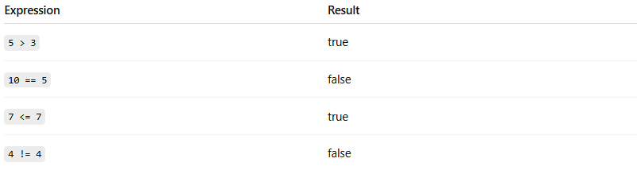
Expression | Result
5 > 3 | true
10 == 5 | false
7 <= 7 | true
4 != 4 | false
Example:
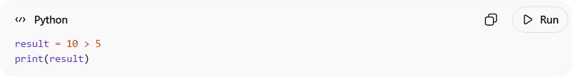
result = 10 > 5
print(result)
Output:
True

Logical Operations with Boolean
# Source: AI Source: Provided by: [Data Path: Persons Table -> ID Column: 1, Name_En Column: Motasem Essam] -> From: [Chatgpt (GPT‑5 Mini)] on [12/10/2025]
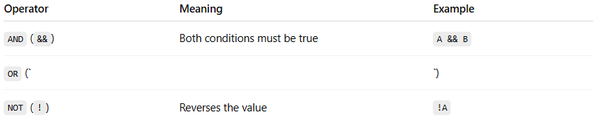
Operator | Meaning | Example
AND (&&) | Both conditions must be true | A && B
OR (` |  | `)
NOT (!) | Reverses the value | !A
Example:
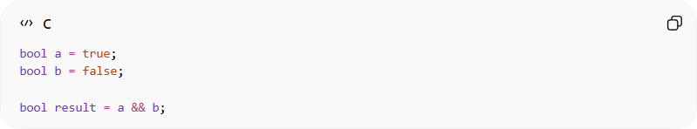
bool a = true;
bool b = false;

bool result = a && b;
Result: false

Real-World Example
# Source: AI Source: Provided by: [Data Path: Persons Table -> ID Column: 1, Name_En Column: Motasem Essam] -> From: [Chatgpt (GPT‑5 Mini)] on [12/10/2025]
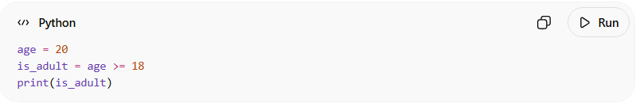
age = 20
is_adult = age >= 18
print(is_adult)
Output:
True

